Building At Maharashtra Nagar.

1. Project Information
- Project Name: __________________
- Location: __________________
- Plot Area: __________________
- Built-up Area: __________________
- Project Type: Large-scale residential redevelopment
- Client/Developer: Transindia Group
- Status: __________________
- Completion Year: __________________

2. Project Overview
A large-scale residential development comprising multiple high-rise wings, commercial frontage and landscaped communal spaces. The project combines efficient residential planning with contemporary façades and integrated lifestyle amenities. Its strong urban scale creates a prominent and unified architectural identity.

3. Building Features
- Multiple high-rise residential wings
- Ground-floor commercial frontage
- Large glazed windows and framed openings
- Strong vertical fins and façade projections
- Decorative crown and illuminated roofline
- Landscaped podium and rooftop terraces
- Swimming pool and deck area
- Children’s play zone
- Outdoor seating and gathering spaces
- Landscaped courtyards and walking paths
- Palm-lined entrance and internal roads
- Integrated façade and landscape lighting

4. Overall Design Concept
The design uses a disciplined grid of vertical fins, horizontal bands and repetitive windows to unify the large building mass. Light neutral façades are enhanced with glazing, textured panels and warm architectural lighting. Landscaped terraces and central amenity courts create active community spaces within the high-density development.

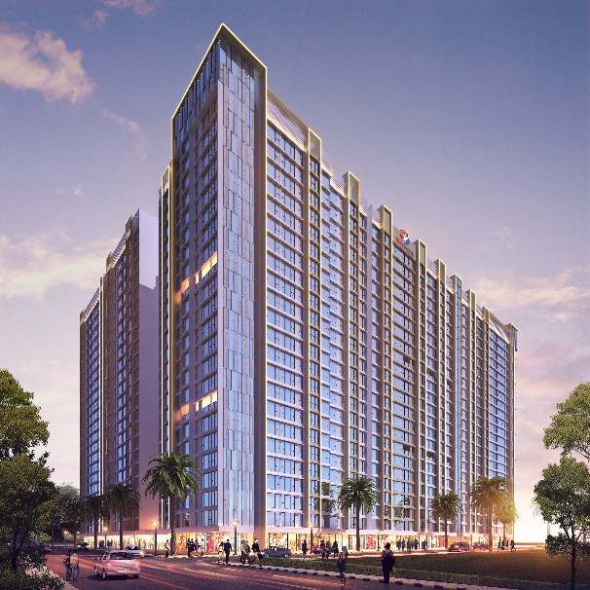
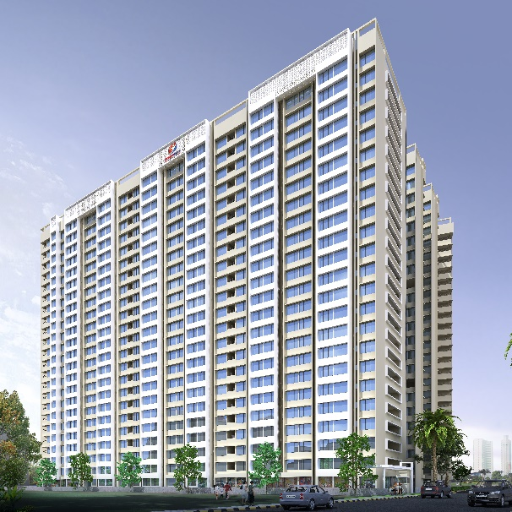
Image 6.
Image 5.
Image 2.
Image 1.

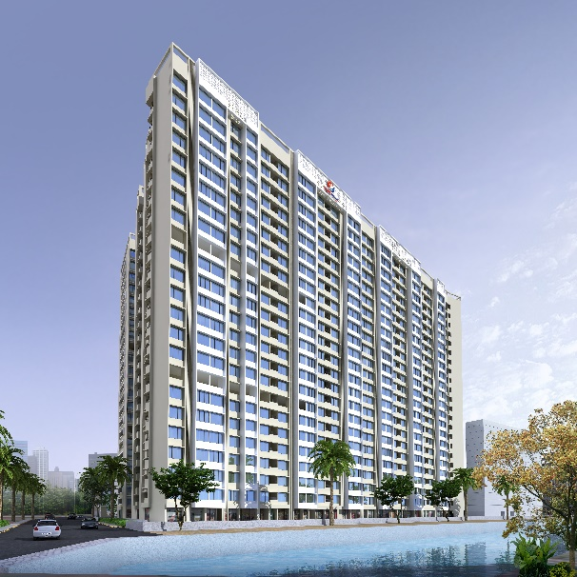
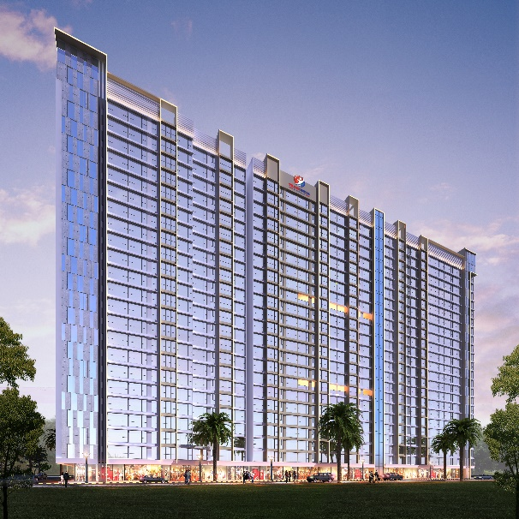

Image 4.
Image 3.
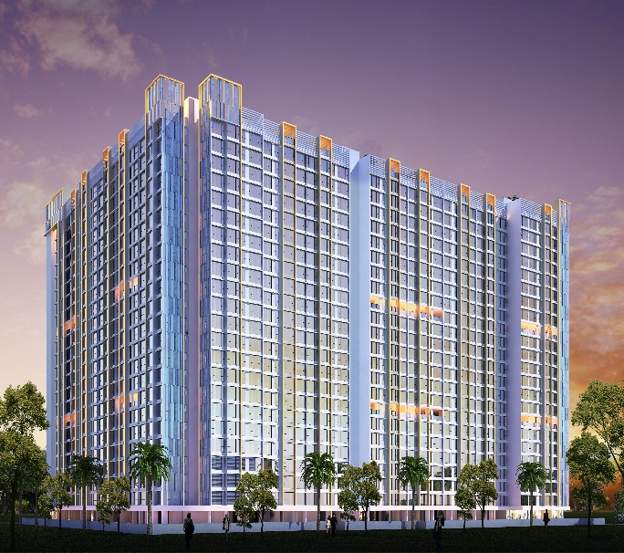
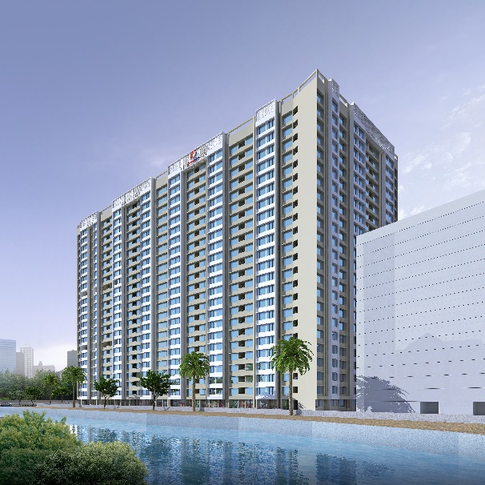
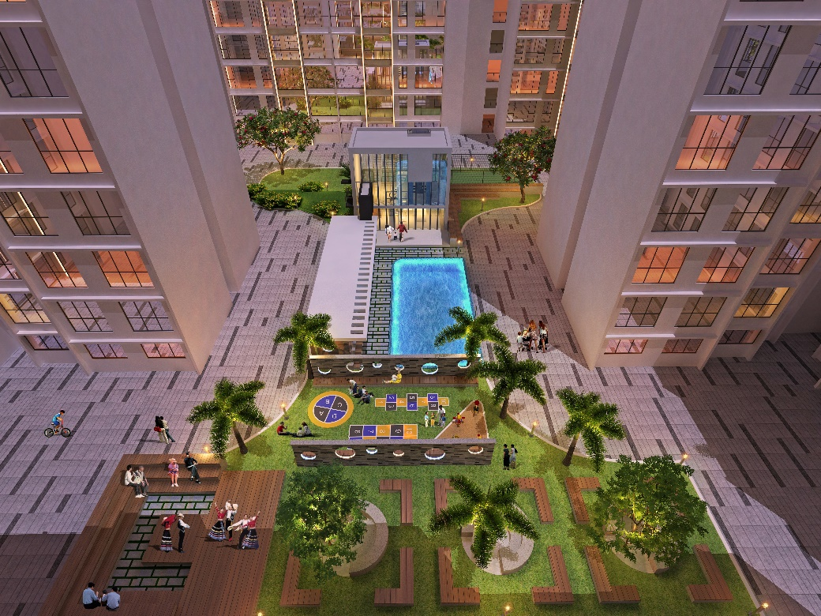
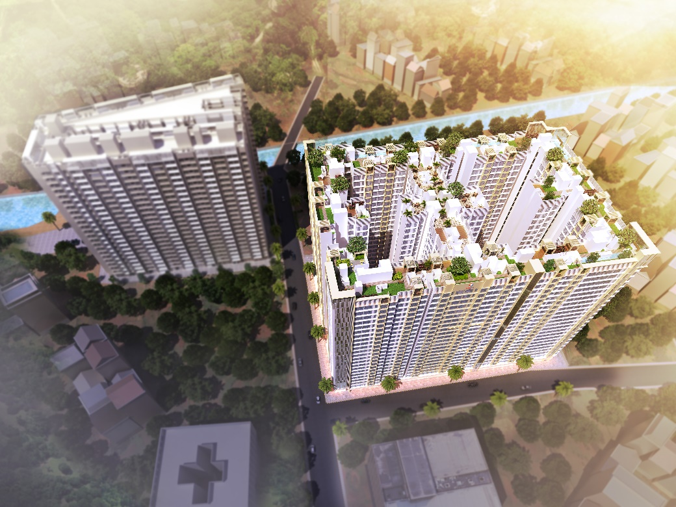
Image 8.
Image 7.

